Western-style five-hole pamphlet stitch
  - Preservation Services, University of Illinois Urbana-Champaign Library
  - Note: Solid lines represent thread inside the pamphlet, dashed lines represent thread on the outside of the pamphlet.
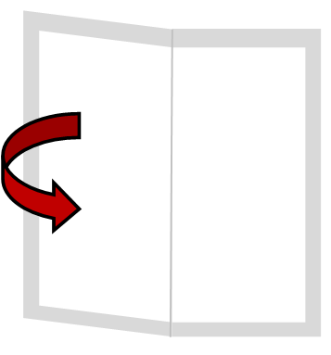  1. Fold the stack of paper in half, with the cover paper on the outside |  |   2. Run a bone folder along the fold to create a secure crease
  3. Unfold the pamphlet and from the inside, use an awl to punch a hole through the center of the fold |  | 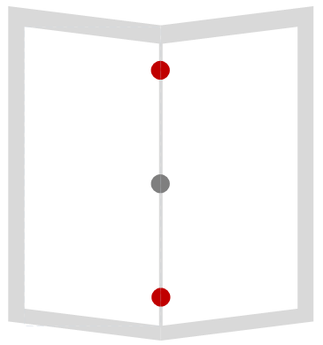  4. Punch two more holes along the fold, equidistant from the top and bottom edge, no closer than ½ inch to the edge
  5. Punch two more holes, halfway between each of the existing holes |  | 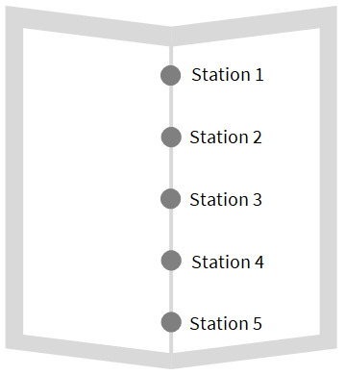  6. Each hole is a sewing station, numbered 1-5 from top to bottom
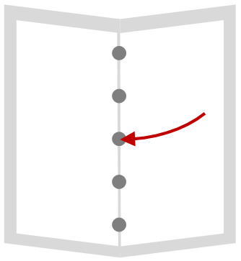  7. Thread your needle and sew from the inside through station 3 toward the outside, leaving a 2-inch tail inside |  | 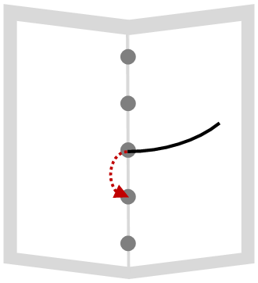  8. Sew through station 4 from the outside of the pamphlet to the inside
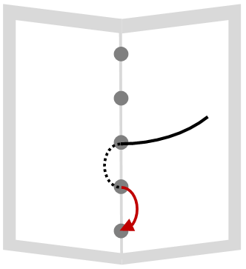  9. Sew through station 5 from inside to the outside |  | 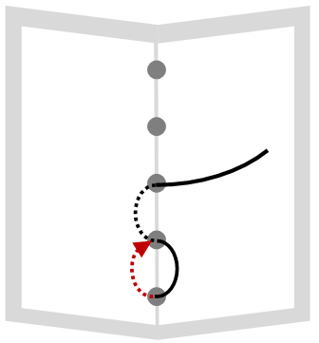  10. Sew through station 4 again from outside to the inside
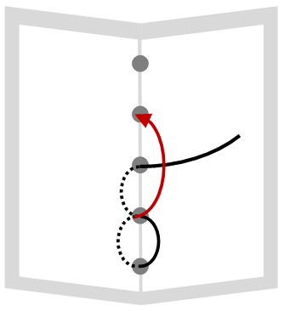  11. Sew through station 2 from inside to the outside |  | 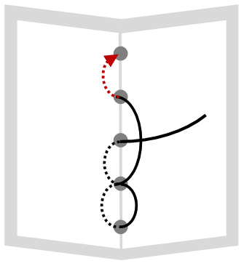  12. Sew through station 1 from outside to the inside
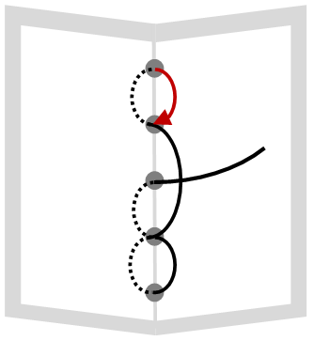  13. Sew through station 2 again from inside to the outside |  | 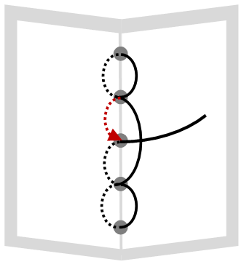  14. Sew through station 3 from outside to the inside
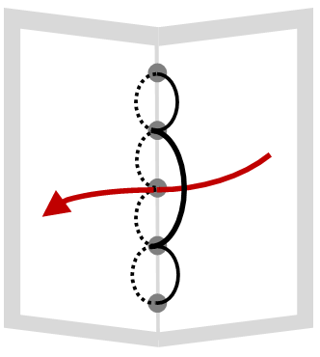  16. Make sure the two loose ends of the thread are on either side of the stitch that runs from station 4 to station 2 |  | 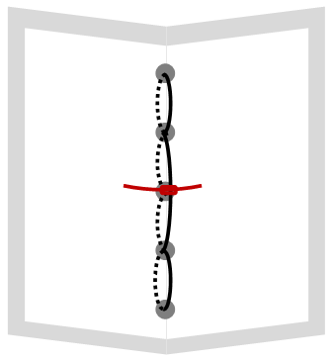  17. Tie the two loose ends of the thread in a square knot and trim the excess thread

