Newberry Library: Bound-With and Analytic Linking

Overview

This document outlines the steps for linking together bibliographic records for separate titles bound together in a single volume and records for analyzed works (maps, articles, etc.) that constitute part of a larger work (for linking purposes, considered the “host” item). Since the host and its constituent units form part of a single volume or item, they must share a holdings and item record. The constituent bib records are linked to the host bib record via the host’s item record.

Instructions

1. Make sure that the bib record for the host item has an item record and that you have imported the bib record for the constituent item(s).

For analytics only: You will have already added a 773 linking field to the bib record at the time of cataloging in OCLC Connexion. Make sure the 773 is present. Follow the pattern in the example below for formatting the 773:

773 08 $$i Contained in (manifestation): $$a Colton, G. Woolworth (George Woolworth), 1827-1901. $$t Colton's atlas of America. $$d New York : J.H. Colton and Co., 1859. $$g pl. [12] $$w (OCoLC)18403428

For more information on constructing 773 fields for host items and additional examples, see OCLC Bibliographic Formats and Standards for the 773 field.

2. Make sure that you move or add any copy-specific, provenance, binding notes, etc. that apply to the whole volume (e.g., 561 note for Newberry collection name, 561 note for bookplate, 563 note describing binding of volume) to the holdings record for the host item.

For analytics only: In the bib record for the host item in the Metadata Editor, add a 774 linking field with creator (1XX), title (245 $a), and OCLC number from the constituent analytic record, following the pattern in the example below:

774 08 $$i Container of (manifestation): $$a Colton, J. H. (Joseph Hutchins), 1800-1893. $$t Colton's Connecticut with portions of New York & Rhode Island. $$g pl. [12] $$w (OCoLC)1159903066

For more information on constructing 774 fields for constituent units and additional examples, see OCLC Bibliographic Formats and Standards for the 774 field.

Save and Release bib record (Save > Save and Release Record OR Ctrl+Alt+R).

3. Open the holdings record of the host item following the instructions for editing holdings records in Holdings Records in Alma. Add a 014 field with the MMS ID of the constituent bib record.

Example:

MMS ID of constituent unit "Colton's Connecticut with portions of New York & Rhode Island" is 998929088805867. Enter 014 for the constituent unit in holdings record of host volume "Colton's atlas of America" (MMS 99744848805867):

014 1_ $$a 998929088805867

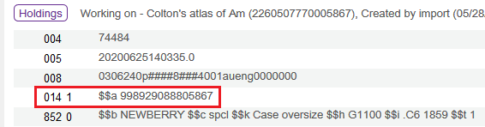

Save and Release holdings record (Save > Save and Release Record OR Ctrl+Alt+R).

4. Open the item record of the host item following the instructions for editing item records in Item Records in Alma. Alma requires barcodes for bound-with and analytic linking. Since we do not use barcodes, we need to create a dummy barcode. In order to create a unique dummy barcode, enter a normalized version of the call number of the host item--omitting prefixes (852 $k), punctuation, and whitespace--into the Barcode field in the item record. Click Save when finished.

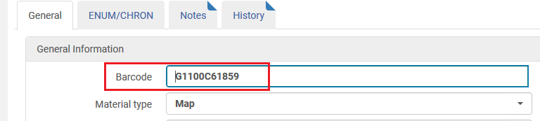

5. Open the bib record for the constituent unit (whether subsequent title in bound-with or analytic) in the MD Editor.

For analytics only: Add $w with MMS ID from host item bib record and $g with barcode from the item record for the host to the end of the existing 773 field. The $g for barcode should include the prefix no: followed by a space, as in: $$g no: G1100C6185912

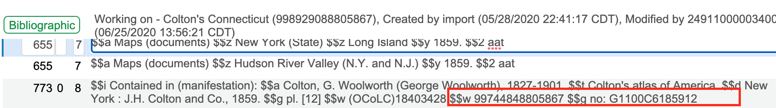

For bound-withs only: Add 773 formatted as follows, including only $t with title and $w with MMS ID from host item bib record preceded by "$$i Bound with" and $g with barcode from item record for the host:

773 0_ $$i Bound with $$t [title from 245 $a of host bib record] $$w [MMS ID from 001 of host bib record] $$g no: [barcode from item record of host] $$9 unrelated:
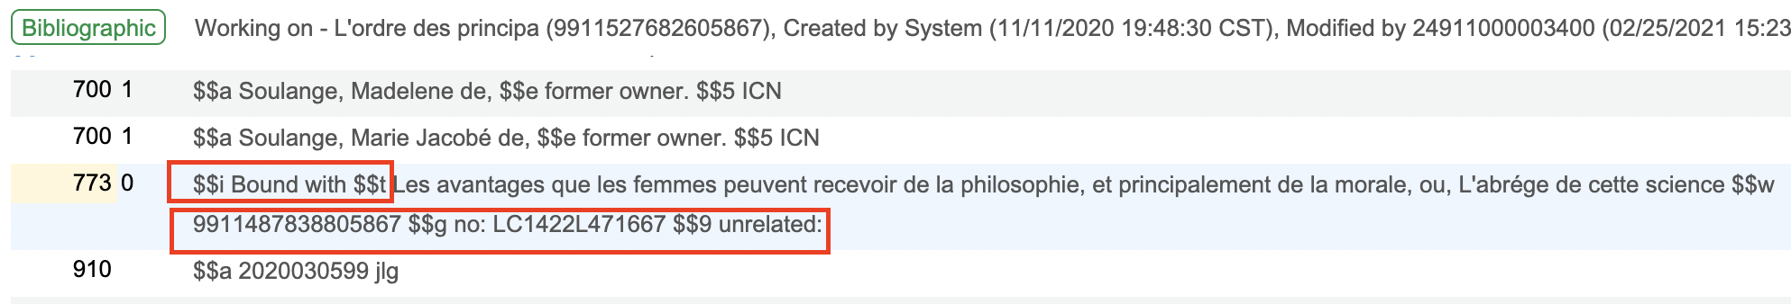

Save and Release bib record (Save > Save and Release Record OR Ctrl+Alt+R).

6. If you have more than one constituent unit to link to the host item, repeat the above steps.

7. Alma will run a job automatically to link the records overnight. The following day, perform a Physical titles search by MMS ID for the constituent unit(s) to verify that the host and constituent records have been linked. You should see that physical inventory is now attached. When you click on Physical to expand, you should see the call number from the holdings record of the host item and a green checkmark next to Related in the Related Record column.

